Lab 22: Spring Dependency Injection

Objective
This lab will introduce you to using dependency injection to implement inversion of control

Step by Step Guide

This lab builds on the previous by creating a dependency between an ITPerson and a Manual. When asked for advice, the ITPerson consults the manual.

This defines a dependency between the two classes. An ITPerson object requires a Manual object to be available.

Spring handles these dependencies by using autowiring and dependency injection. This lab will only use constructor injection.

Step by Step Instructions

In this lab, you will be creating a standard Java project that uses the Spring via adding the Spring Framework jar files to the build path just like in the previous lab. You will also reuse some of the same code that you used in the previous lab.

Setup the new project

- Create a new Project in your workspace named Consult2.
- Add the Spring jar files to the build path exactly as you did in the previous lab.
- Create the Consultant interface exactly like the previous lab

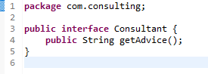

- You also need to create a Manual interface that has “lookup” method that returns a string

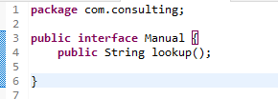

Create the Classes

- Create a class called ITManual that implements the Manual interface

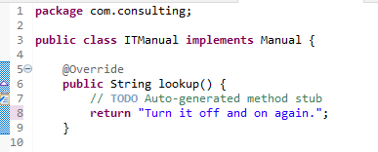
- Create an implementation called “ITPerson” that implements the interface and consults the manual when asked for advice

- In order to do this, you are going to have to have a reference to a manual that the ITPerson can use. This is done by having private instance variable refencing a manual object

- Add a constructor that takes an instance of a manual and passes it the ITPerson object when it is created

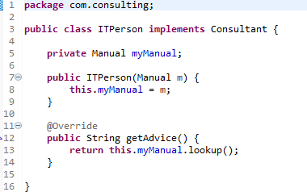

Create the application manually

- First, you will get the application running by doing the dependency is resolved manually by creating a Manual object and then passes it to the ITPerson object at construction time.

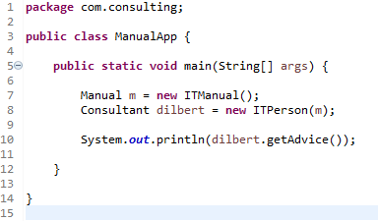
- Run the code. You managed the dependencies manually. This is easy to do with a simple example like this, but when there are large chains of dependencies, this becomes very difficult to do.
Springify the application

- Add the same XML config fine in the src directory that you used in the last lab.
<?xml version="1.0" encoding="UTF-8"?>
<beans xmlns="http://www.springframework.org/schema/beans"
xmlns:xsi="http://www.w3.org/2001/XMLSchema-instance"
xmlns:context="http://www.springframework.org/schema/context"
xsi:schemaLocation="http://www.springframework.org/schema/beans
http://www.springframework.org/schema/beans/spring-beans.xsd
http://www.springframework.org/schema/context
http://www.springframework.org/schema/context/spring-context.xsd">

<!-- add entry to enable component scanning -->

<context:component-scan base-package="com.consuting" />

</beans>

Create the Annotations of the Components

- Add the @Component annotation to the two ITPerson and Manual classes: exactly like you did in the previous lab

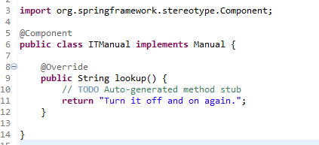
.
Create the Autowiring

- In the ITPerson class, annotate the constructor with the @Autowired annotation

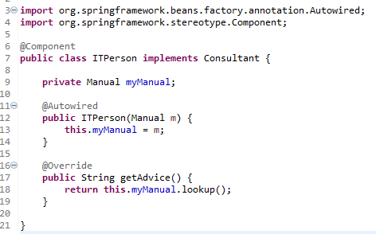

Automate the DI

- The code does not have to do any dependency resolution
- The
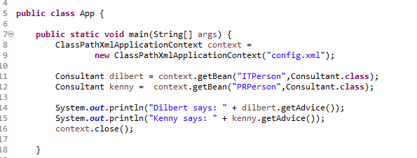

- To see that you are working with singletons, compare two ITPerson beans to see if they resolve to the same object address in memory.

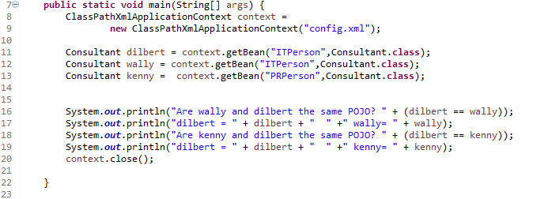
- The output of the above should look like this

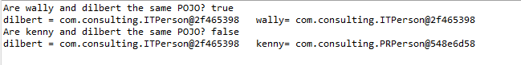
Prototype Beans

- You can specify that every time a bean is created from a class, a new instance of the POJO is used.
- The @Scope annotation is used
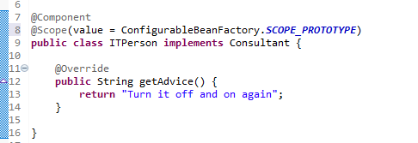

- Adding the annotation and rerunning the application without any other changes will show that the two ITPerson beans are distinct instances

